Retail AI — Use Case 1
Demand Planning and Consumer/member Loop
Forward Deploy Consulting · May 2026 · Confidential

Index
- Dictionary of Terms
- Use case and Problem statement
- Impact
- Impacted Domains & Systems
- As is and To Be process flows
- Blind spots/Friction Points
- Solution and Requirement
  - In Scope
  - Out of Scope
  - Assumptions
- Implementation Approach
- Business Glossary + Data Standards
- Taxonomy — Excel — Tab 2
- Data Dictionary
- Ontology — Excel — Tab 4
- Semantic Layer — Excel — Tab 5

- Dictionary –
Term | Description
Planning Loop | The end-to-end flow of inventory decisions: product data from Line Plan → Product Data Hub → ERP/WMS/.com and sales signals back into demand forecasting, allocation and replenishment.
Consumer Loop | The end-to-end flow of customer activity: touchpoints (store, .com, app), transactions, intent signals (browse, search, wishlist), identity resolution, analytics, segmentation and marketing activation.
Connected Loop
FP – Friction Points
Human in the loop | A design principle where AI agents propose recommendations that a planner, buyer, or merchant reviews and approves before action is taken. No agent acts autonomously on planning decisions without human approval in Phas

- Context and Problem statement
  - The core problem: Customer Intelligence is disconnected from Inventory Intelligence.

  - Context -
Retail planning makes billion-dollar inventory decisions - what to buy, how much, where to send it, when to markdown etc but they are using one input: historical sales data. That signal is aggregate, backward-looking, delayed and incomplete.
Meanwhile, the consumer side of the business generates rich, real-time intelligence about what customers want: what they are searching for, what they are saving, what they are returning and why and what Data Science models predict they will do next. This intelligence stays entirely within the marketing and analytics stack. It is used for executive dashboards but not for planning
The two loops run in parallel. The consumer loop does not know what Planning decided. Planning does not know what consumers are signalling.

Why This Matters Now
Retail has invested heavily in AI and Data Science. 89% of retailers are piloting AI; only 33% have deployed it at scale. The gap is not a technology gap. It is a data and connection gap. The models exist. The signals exist. The connection between them does not.
This use case builds the connection.

Friction Points due to disconnect between the two

ID | Description | Type | Priority | Impact
FP1 | Identity Fragmentation — The same customer exists as 3+ separate records across POS, .com, CRM, and loyalty. No master ID links them. All downstream analytics (CLV, affinity, churn) are built on a fractured sample. Nothing downstream works reliably until identity is resolved. | Data | High | All consumer-to-planning signals are unreliable until this is fixed. Every other FP fix depends on this.
FP2 | Clickstream Data Siloed in .com — Browse queries, add-to-cart, save-for-later, and wishlist events sit in Adobe Analytics or GA4. They never reach Planning. The signal that says "customers are searching for a product and not finding it" never triggers a buy decision. | Integration | High | Demand forecast misses the forward demand signal entirely. Planning always reacts to past sales, never anticipates future demand.
FP3 | Repeat Purchase Signal Not Modeled — For repeat-purchase categories, purchase history contains an implicit replacement cadence. This signal exists in transaction history but is never modelled and never reaches Planning. Demand spikes are reactive, not anticipated. | Data+ Integration | Medium | Replenishment and buy decisions are triggered after demand appears in sales data — always too late.
FP4 | Promotion Response Not Fed Back to Planning — When a promotion runs, Planning has no visibility into which customer segments responded or whether lift was incremental vs. pull-forward. The forecast signal cannot be cleaned after a promotional event. | Integration | Medium | Forecast is polluted by promo-induced demand. Planning cannot distinguish genuine demand from discount-driven pull-forward. Accuracy degrades around every promotional period.
FP5 | Data Science Output Stays in Marketing and personalization — Recommendation engines, churn scores, demand signals, and affinity models built by Data Science stay entirely inside the marketing stack. Planning never sees them. The intelligence already exists — only the routing to Planning is missing. | Integration | High- Bigger ROI | Planning ignores the most sophisticated intelligence the company has built. CLV, affinity, and demand sensing models produce dashboards, not buy decisions.
FP6 | Guest Purchases Invisible — Non-loyalty customers are invisible in CRM. All CLV, churn, and demand analysis is built on a members-only sample — a biased and incomplete picture of actual customer demand. A guest spending $2,000/year at full price is indistinguishable from noise. | Data + Integration | High | Demand forecast is built on a subset of customers. Buy and assortment decisions misrepresent the true demand base.
FP7 | Member Sales Not Attributed in Planning — Planning receives aggregate sales data only. The "who bought" is stripped before it reaches the forecast model. A retailer can be losing members in a specific category while total sales look flat — entirely invisible without member attribution. |  |  | Planning cannot see member-driven demand separately from total demand. Loyalty signal is invisible to the people making buy decisions

Solutions Approach
The solution we propose is to build a connection between the two systems.
The solution has two parts, sequenced deliberately. Data and pipeline issues must be fixed before agents are deployed. Agents built on broken data produce recommendations nobody trusts.
Part 1 — Fix the Data Foundation (Prerequisite) Build the clean, identity-resolved, connected data layer that the agentic workflow will reason over.
Part 2 — Build the Agentic Layer (Value delivery) Deploy AI agents that turn the clean, connected signals into planning decisions — proposed to human planners for review and approval.

4.1- SenseAct Delivery Model-
SenseAct brings pre-built canonical data models and pre-built agents to each client engagement. The architecture is:

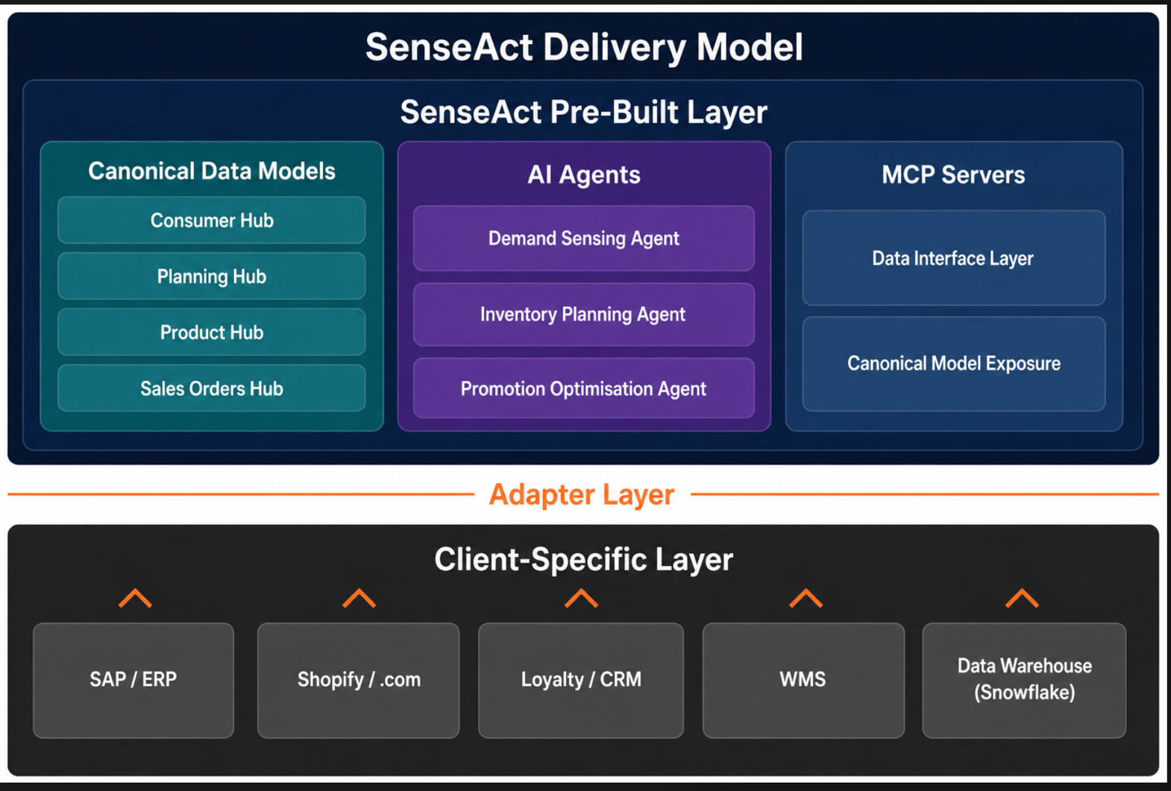

Requirements
  - Business Requirements –
ID | Description | Friction Point
 | Demand forecast must incorporate consumer intent signals (browse, search, wishlist) in addition to historical sales data | FP2
 | Planners must be able to see member-attributed demand separately from total aggregate demand | FP7
 | Forecast signal must be separable into genuine demand vs. promotion-induced demand after any promotional event | FP4
 | Data Science outputs (CLV, category affinity, demand signals) must be routable to Planning — not only to Marketing | FP5
 | All consumer signals reaching Planning must be tied to a single resolved customer identity | FP1
 | Demand analysis must include guest customers, not only loyalty members | FP6
 | Repeat-purchase categories must have a modeled replacement cadence signal available to Planning | FP3

  - Integration Requirements
.com analytics events streamed in near real-time to central data lake
All customer IDs resolved into a single master_id via Identity Graph
Sales transactions joined to master_id before being delivered to Planning system
Data Science model outputs routed to Planning data products (not only to CRM/Marketing)
Client source systems connected to SenseAct canonical data model via adapters

In Scope Domains & Systems

6.1 Domains
1. Consumer & Member The origin of the demand signal that is currently missing from Planning. Includes customer identity, loyalty membership, browse and purchase behavior, returns and Data Science outputs (CLV, churn, affinity).
- Loyalty / member attributes and activity
- Browse and intent signals (.com, app)
- Transaction and return history at individual level
- Data Science model outputs (CLV score, churn risk, category affinity)
2. Deman Planning and Forecasting - The consuming domain. Makes demand forecasts, buy decisions, allocation plans and replenishment calls. Currently operates on aggregate, anonymous, stale sales data.
- Demand forecasting
- Buy quantity and OTB management
- Allocation and replenishment
- Inventory positioning by geography
3. Product Provides the product dimension that not only links consumer signals to planning decisions but drives the operations at the enterprise level. A consumer browsing "heavyweight parkas" must be matched to a specific style/SKU in the assortment for the signal to be actionable.
- Product Line Plan
- PLM / Product Data Hub
- Item Master / UPC
- Category, style, SKU, size, colorway attributes
4. Sales Orders The transactional record that currently forms the entirety of Planning's input signal. With consumer data added, this becomes one input among several — and can be disaggregated by member vs. guest.
- Store POS transactions
- .com / OMS orders and returns
- Return reason codes (currently unstructured or absent)

6.2 Impacted Systems/Applications

7. As-Is and To-Be Process Flows
The process flows are here - https://miro.com/app/board/uXjVHNyyZ1Q=/?focusWidget=3458764644104209191
  - Assumptions
  - In Scope
- Use Case 1 only: Consumer loop + Planning loop connection. UC2 (Costing) and UC3 (Inventory real-time) are out of scope for this document.
- Demand forecasting as the anchor use case and Show & Tell POC. The 5 planning swim lanes (demand forecasting, inventory planning, supply planning, costing, material planning) are SenseAct's full positioning — the starting point is demand forecasting.
- Consumer hub and Planning hub data definitions at the aggregated / hub level. Not individual upstream source tables (45–50 source tables upstream of the hub are out of scope for initial definition).
- Mid-market retail target ($100M–$500M revenue): companies that have ERP, loyalty/CRM, and .com systems but have not integrated them. Nike-scale architecture is the reference model; mid-market is the target client profile.
- Three AI agents: Demand Sensing (anchor), Inventory Planning, Promotion Optimisation.
- SenseAct canonical data model — consumer hub, planning hub, product hub, sales orders hub — with adapter-layer approach for client system integration.
- Data governance framework as a deliverable of Phase 1 — ontology, taxonomy, data quality SLAs
  - Out of Scope
- UC2 — Costing Loop: Landed cost calculation, PLM ↔ Planning cost negotiation, tariff real-time updates. Separate document.
- UC3 — Inventory + Planning (real-time): POS real-time streaming to Planning, DC blind spot, manual allocation handoff. Separate document.
- Deferred FPs (UC3+): Returns → PLM feedback, inventory-triggered markdown activation, post-purchase → product design, loyalty operationalisation. These FPs touch current inventory management or PLM feedback loops — numbered FP8 onwards in UC2/UC3 documents.
- Full upstream source system build: The 45–50 upstream tables that feed the planning hub (individual ERP tables, WMS tables, etc.) are not in scope. SenseAct works at the hub / aggregated level and builds adapters to accept client data at that level.
- UI / front-end build: Planning interfaces, dashboards, and merchant-facing UI are not built by SenseAct in Phase 1 or 2. Agents surface recommendations through existing planning tools, email, or Teams/WhatsApp channels. Custom UI is a Phase 3+ consideration.
- Data science model build (from scratch): SenseAct assumes client Data Science models exist (CLV, churn, affinity). Phase 2 routes existing outputs to Planning — it does not rebuild Data Science models. If models do not exist, this is a separate scoping conversation.
- Model fine-tuning and drift management: Academic knowledge area; not committed to Phase 2 scope. Gray area — to be addressed as the engagement progresses.
- Full loyalty program redesign: FP6 and FP12 are addressed at the data routing and agent layer. Redesign of the loyalty program itself (points structure, earn/burn, partner program ) is not in scope.
- Full Data Governance – Client will need to define the DG principals and frameworks

